TITLE : - INDIAN KIDS SCREEN TIME ANALYSIS

ABSTRACT

This project presents a comprehensive analysis of screen time behavior among Indian children.
The study explores patterns based on age, gender, location (urban vs rural), and device usage.
Using data visualization and business intelligence tools, meaningful insights were derived to understand how children interact with digital devices.
The dashboard highlights key performance indicators such as average screen time, device distribution, and health impacts.
The findings emphasize the growing concern of excessive screen exposure and its effects on physical and mental well-being.
This project aims to support parents, educators, and policymakers in making informed decisions regarding children's digital habits.

INTRODUCTION

In the modern digital era, technology has become an integral part of children's lives.
From online education to entertainment, screens are used extensively throughout the day.
However, excessive usage can lead to serious health issues such as eye strain, sleep disorders, obesity, and reduced social interaction.
This project focuses on analyzing screen time data of Indian children to identify usage patterns and trends.
The main objective is to provide a clear understanding of how screen time varies across different demographic factors.
The study also aims to:
- Identify high-risk groups with excessive screen usage
- Compare educational vs recreational usage
- Analyze device preferences among children
- Understand the impact of location (urban vs rural)
The insights gained from this project can help in creating awareness and promoting balanced digital usage among children..

DATASET DESCRIPTION

The dataset used in this project contains information about children's screen time behavior.
Key attributes include:
- Age: Represents the age of the child
- Gender: Male/Female
- Avg Daily Screen Time: Average hours spent on screens
- Primary Device: Smartphone, Tablet, TV, Laptop
- Location: Urban or Rural
- Educational vs Recreational Usage
- Health Impacts
The dataset consists of 82 records, providing a sample representation of children's digital behavior patterns.

DATA CLEANING & PROCESSING

Data preprocessing is an essential step to ensure accuracy and consistency.
The following steps were performed:
- Removed duplicate records to avoid redundancy
- Handled missing values using appropriate techniques
- Standardized categorical values (e.g., gender labels)
- Converted numerical columns into correct data types
- Verified data consistency and integrity
Feature Engineering:
- Created ratio between educational and recreational usage
- Grouped ages into categories for better analysis
- Derived insights from existing attributes
These steps ensured that the dataset was clean, structured, and ready for analysis.

EXPLORATORY DATA ANALYSIS

Exploratory Data Analysis (EDA) was performed to understand the dataset.
Univariate Analysis:
- Distribution of screen time
- Device usage frequency
- Age group distribution
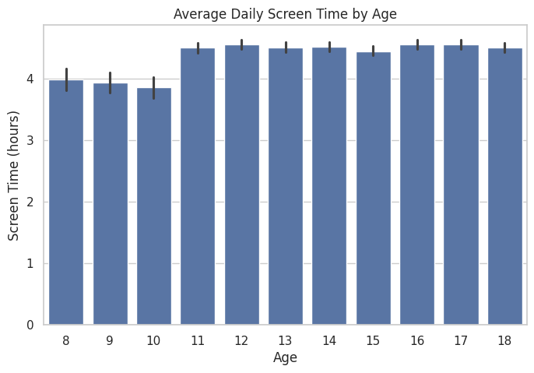
Bivariate Analysis:
- Screen time by gender
- Screen time by age
- Device usage by location
Visualization Techniques:
- Bar charts for comparisons
- Line charts for trends
- Pie charts for distribution
- Donut charts for categorical analysis
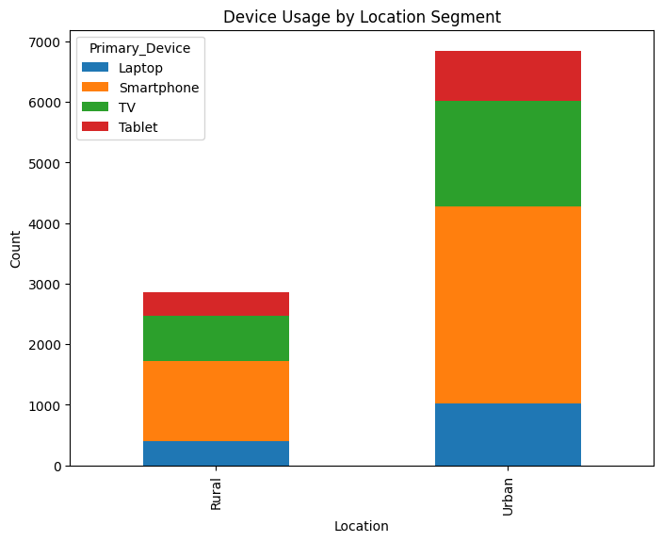
EDA helped in identifying key trends and patterns within the dataset.

DATA MODELING

The data model was designed using Power BI.
A star schema approach was implemented:
- Fact Table: Contains screen time data
- Dimension Tables: Age, Gender, Device, Location
Relationships:
- Each dimension is connected to the fact table using one-to-many relationships
This structure improves performance and enables efficient filtering and slicing in the dashboard.

DAX FORMULAS

The following DAX formulas were used:
Average Screen Time:
Avg_Screen_Time = AVERAGE('Table'[Avg_Daily_Screen_Time_hr])
Total Kids:
Total_Kids = COUNT('Table'[Child_ID])
Kids Exceeding Limit:
Kids_Exceeding_Limit = CALCULATE(COUNT('Table'[Child_ID]), 'Table'[Avg_Daily_Screen_Time_hr] > 2)
Educational vs Recreational Ratio:
Edu_Recreational_Ratio = DIVIDE(AVERAGE('Table'[Educational_Time]), AVERAGE('Table'[Recreational_Time]))
Urban Count:
Urban_Count = CALCULATE(COUNT('Table'[Child_ID]), 'Table'[Urban_or_Rural] = "Urban")

DASHBOARD ANALYSIS

The dashboard provides several key insights:
- Average screen time is significantly high (4.21 hours)
- All children exceed the recommended screen time limit
- Smartphones are the most commonly used devices
- Urban children have higher screen exposure than rural children
- Screen time increases with age
Health Impacts:
- Poor sleep patterns
- Eye strain
- Reduced physical activity
These insights highlight the importance of monitoring and controlling screen usage among children.

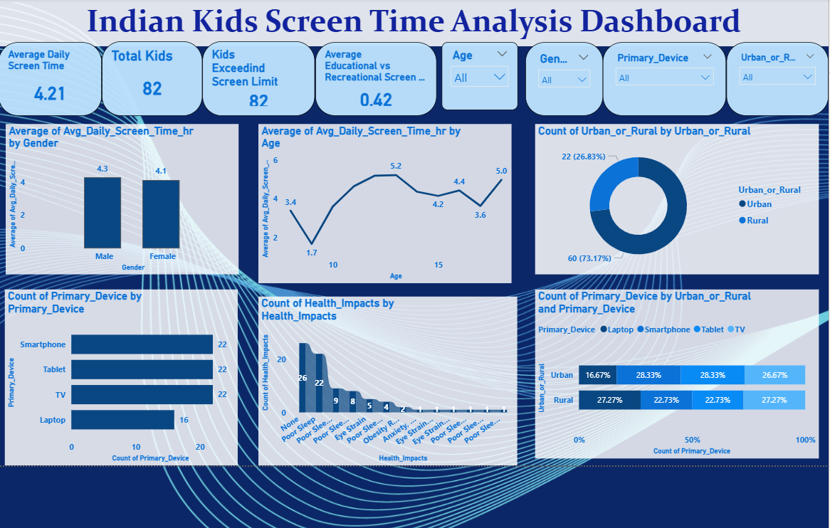

TOOLS & TECHNOLOGIES

The following tools were used:
- Python (Pandas, NumPy): Data cleaning and preprocessing
- Power BI: Dashboard creation and visualization
These tools helped in transforming raw data into meaningful insights.

ADVANTAGES OF THE STUDY

- Provides clear visualization of screen time patterns
- Helps identify high-risk groups
- Supports decision-making for parents and educators
- Enhances understanding of digital behavior among children

CONCLUSION

This project successfully analyzes screen time behavior among Indian children.
The results indicate excessive screen usage and its potential health risks.
The dashboard provides a clear and interactive way to understand patterns and trends.
It emphasizes the need for balanced screen usage and awareness among stakeholders.
Overall, the project demonstrates the power of data visualization in solving real-world problems and supporting better decision-making.

